

V 1.2
June 2026
XStep Design Specification
SMPL: Goods Receipt

Table of Contents
1 Purpose 3
2 Overview 3
3 Reasons for Developing 4
4 Authorization 4
5 Assumptions/Dependencies 4
6 Security Objects 4
7 Validation Checks 4
8 Configuration Specification 4
9 Xstep Layout Design 5
10 Functional Module(s) 5
11 Pseudocode 5
12 Test Scenarios 5
13 Revision History 6

Purpose
This document outlines the design, as well as the configuration specifications for the XStep “SMPL: Goods Receipt”.

Overview
The purpose of the SMPL: Goods Receipt XStep is to summarize the critical finished product information linked to the process order and perform the necessary inventory and financial record updates in SAP.
The XStep contains the following main input parameters:
- IV_HEADER - The default header text can be edited in SIMPL MBR to display the specific header text for the XStep.
- IV_INSTR - The default instruction text can be edited in SIMPL MBR to display the specific header text for the XStep.
- IV_SIGN – This can be changed in SiMPL MBR to author standalone signatures as part of the xstep.
The process order is generated. After completion of the entire process to create the finished product, the operator utilizes the SMPL: Goods Receipt XStep to verify the process order information prior to signoff and process completion.
The following fields are automatically populated prior to execution of the XStep:
- The Material field automatically populates the material number.
- The Material Description field automatically populates the description attached to the material.
- The Batch field automatically populates the batch number of the set of finished goods manufactured.
- The Quantity field automatically populates the quantity of the finished product within the manufactured batch, but allows for change if the quantity needs to be adjusted.
- The UoM field automatically populates the unit of measure associated with the manufactured finished product.

Functional Design
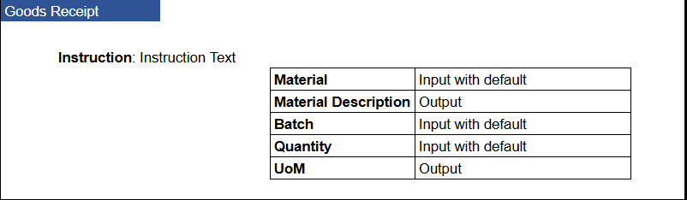

Reasons for Developing
The SMPL: Goods Receipt XStep serves as a record of the manufactured materials after completion of the entire process. The XStep retrieves the critical details linked to the process order, namely the Material, Material Description, Batch, Quantity and UoM and ensures record is kept of the finished product manufactured. After execution of the XStep, the relevant details and quantities are updated within SAP.

Authorization
N/A

Assumptions/Dependencies
N/A

Security Objects
Object Name | Description
Signature validation | Optional

Validation Checks
N/A

Configuration Specification
Goods Receipt Configuration (PI_PROD)
The process message PI_PROD is used to communicate goods receipt data from the XStep execution to the backend system. This message handles material material receipt postings (typically movement type 561) for the components used in production. During execution, the XStep collects and transfers relevant component data such as material number, batch, received quantity, unit of measure, storage location. The message is triggered upon confirmation of the Goods Receipt XStep fields and ensures that the component receipt is correctly reflected in the process order. All generated process messages are captured in transaction CO54, where they can be monitored and processed/sent. Configuration of PI_PROD allows flexible mapping of input parameters and supports integration with both standard and custom logic for inventory updates and traceability.

Xstep Layout Design
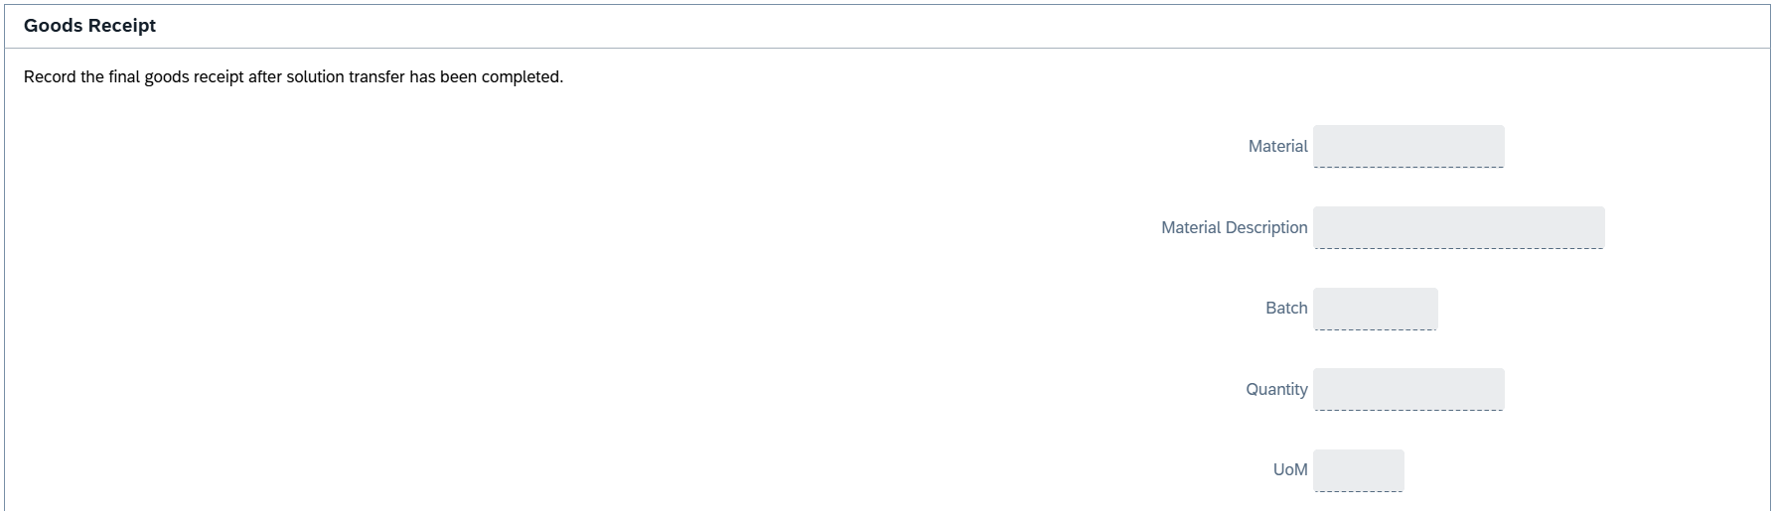

Function Module(s)

Pseudocode

Test Scenarios
# | Scenario | Expected Result | Actual Result | Pass/ Fail
1 | Create and Release a Process Order with the pre-configured SiMPL Master Recipe and the relevant Production Version | Process Order created and Released containing SMPL: Goods Receipt | Process Order created and Released containing SMPL: Goods Receipt
2 | Open the EBR, and navigate to SMPL: Goods Receipt | The EBR for the selected Process Order and Control Recipe opens successfully without any errors and the SMPL: Goods Receipt is visible | The EBR for the selected Process Order and Control Recipe opens successfully without any errors and the SMPL: Goods Receipt is visible
3 | The operator confirms that the order information such as material, batch, and order quantity is pre-populated. | Planned Order information is displayed correctly in the Goods Receipt fields. | Planned Order information is displayed correctly in the Goods Receipt fields.
4 | Enter a username in the “Performed By” field then enter the password in the pop-up window. | Signature is accepted | Signature is accepted
5 | Navigate to transaction CO54 to ensure process message is created successfully for goods issued on the current order | Process message exists with the correct details. | Process message exists with the correct details.

Revision History
Version No. | Description | Author | Date
1.1 | Initial Document | Jason Craig | 31-10-2025
1.2 | The following Technical Spec sections added to spec: Function Module(s), and Pseudocode. (WIP) | Chelsea Hsieh | 22-06-2026

